1. Create an ER diagram for the given airlines database.

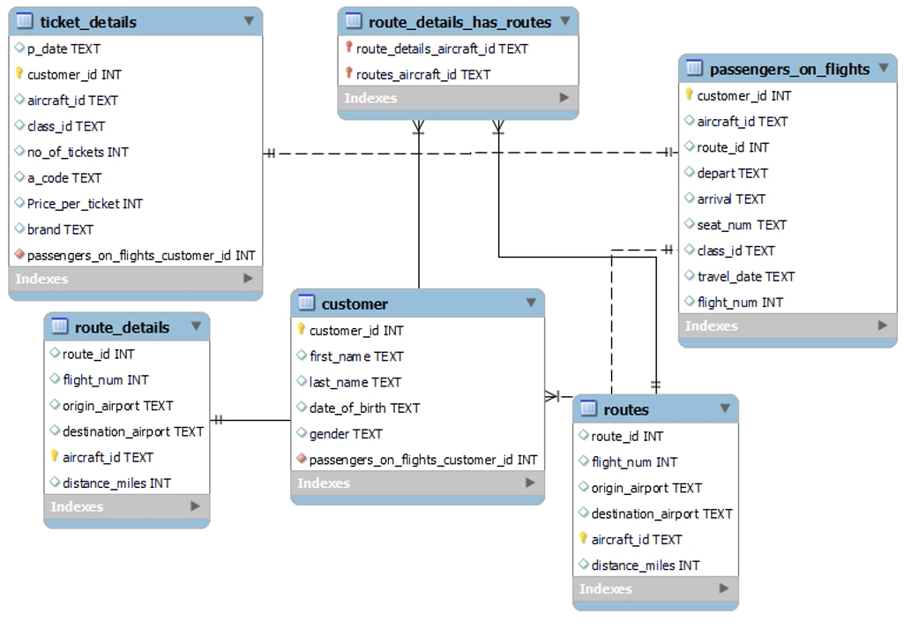

1. Write a query to create route_details table using suitable data types for the fields, such as route_id, flight_num, origin_airport, destination_airport, aircraft_id, and distance_miles. Implement the check constraint for the flight number and unique constraint for the route_id fields. Also, make sure that the distance miles field is greater than 0.

**QUERY:** **CREATE TABLE rounte_details (**

**route_id INTEGER NOT NULL AUTO_INCREMENT,**

**flight_num INTEGER NOT NULL UNIQUE,**

**origin_airport VARCHAR(255) NOT NULL,**

**destination_airport VARCHAR(255) NOT NULL,**

**aircraft_id VARCHAR(255) NOT NULL,**

**distance_miles INTEGER NOT NULL,**

**CONSTRAINT r_id_unq PRIMARY KEY(route_id),**

**CONSTRAINT f_num_check CHECK ((substr(flight_num,1,2=11))),**

**CONSTRAINT r_id_unq CHECK (distance_miles>0)**

**)**

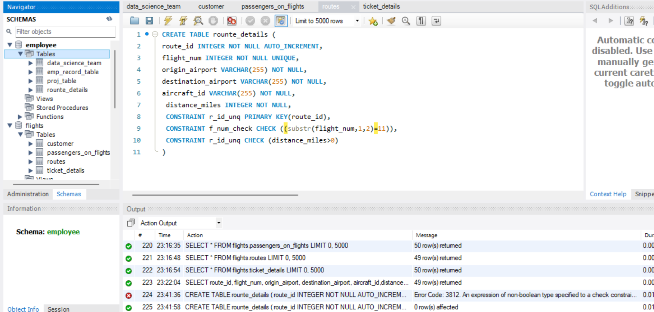

1. Write a query to display all the passengers (customers) who have travelled in routes 01 to 25. Take data  from the passengers_on_flights table.

**QUERY:** SELECT * FROM flights.passengers_on_flights

WHERE route_id BETWEEN 1 and 25 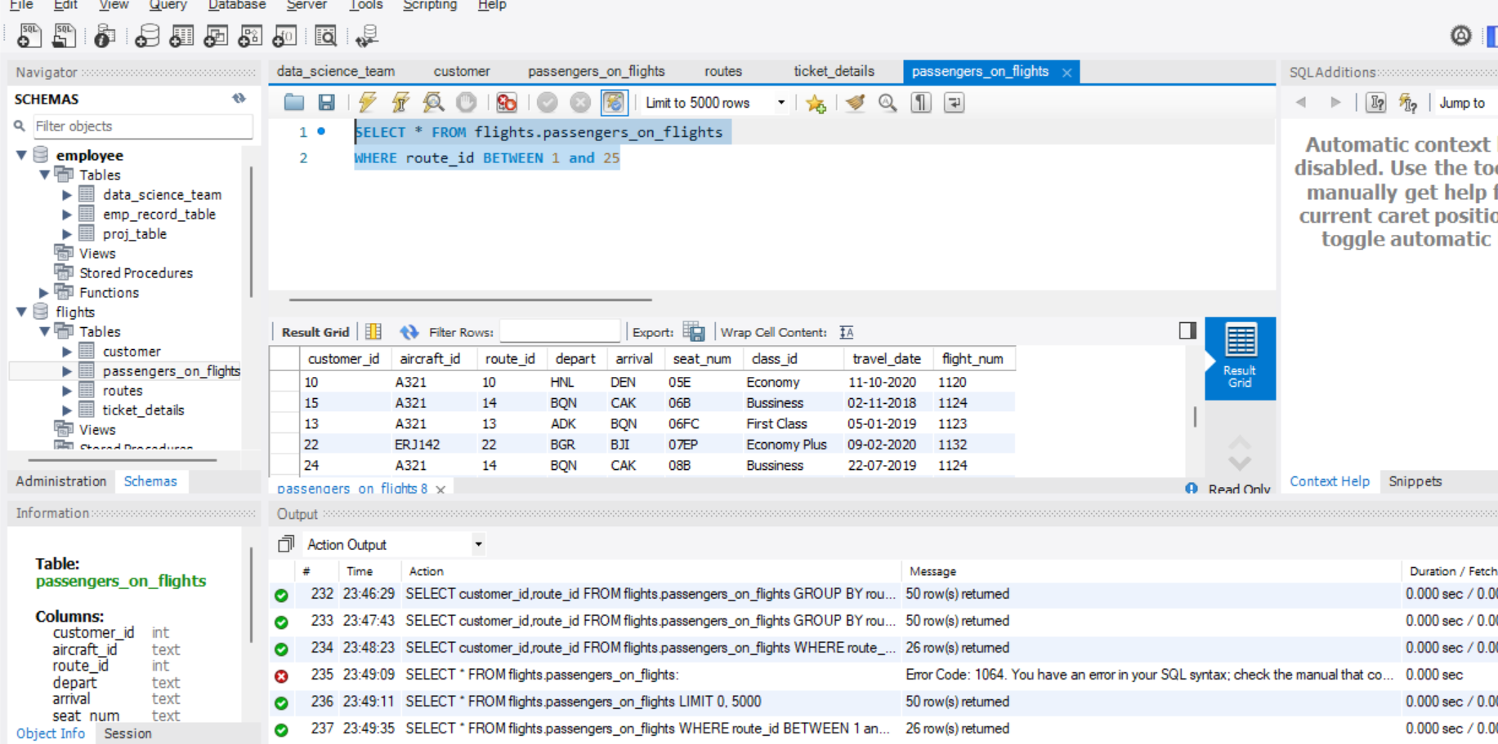

1. Write a query to identify the number of passengers and total revenue in business class from the ticket_details table.

**QUERY: SELECT class_id,COUNT(class_id) AS 'NO_of_passenger',SUM(Price_per_ticket) as 'total_revenue'FROM flights.ticket_details**

**WHERE class_id = 'Bussiness'**

**GROUP BY class_id** 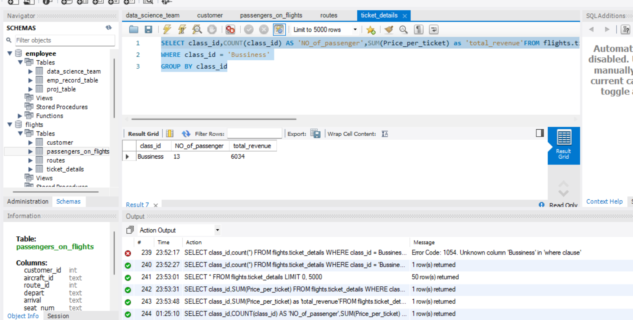

1. Write a query to display the full name of the customer by extracting the first name and last name from the customer table.

**QUERY: SELECT CONCAT(first_name,' ',last_name) AS 'full_name' FROM flights.customer;** 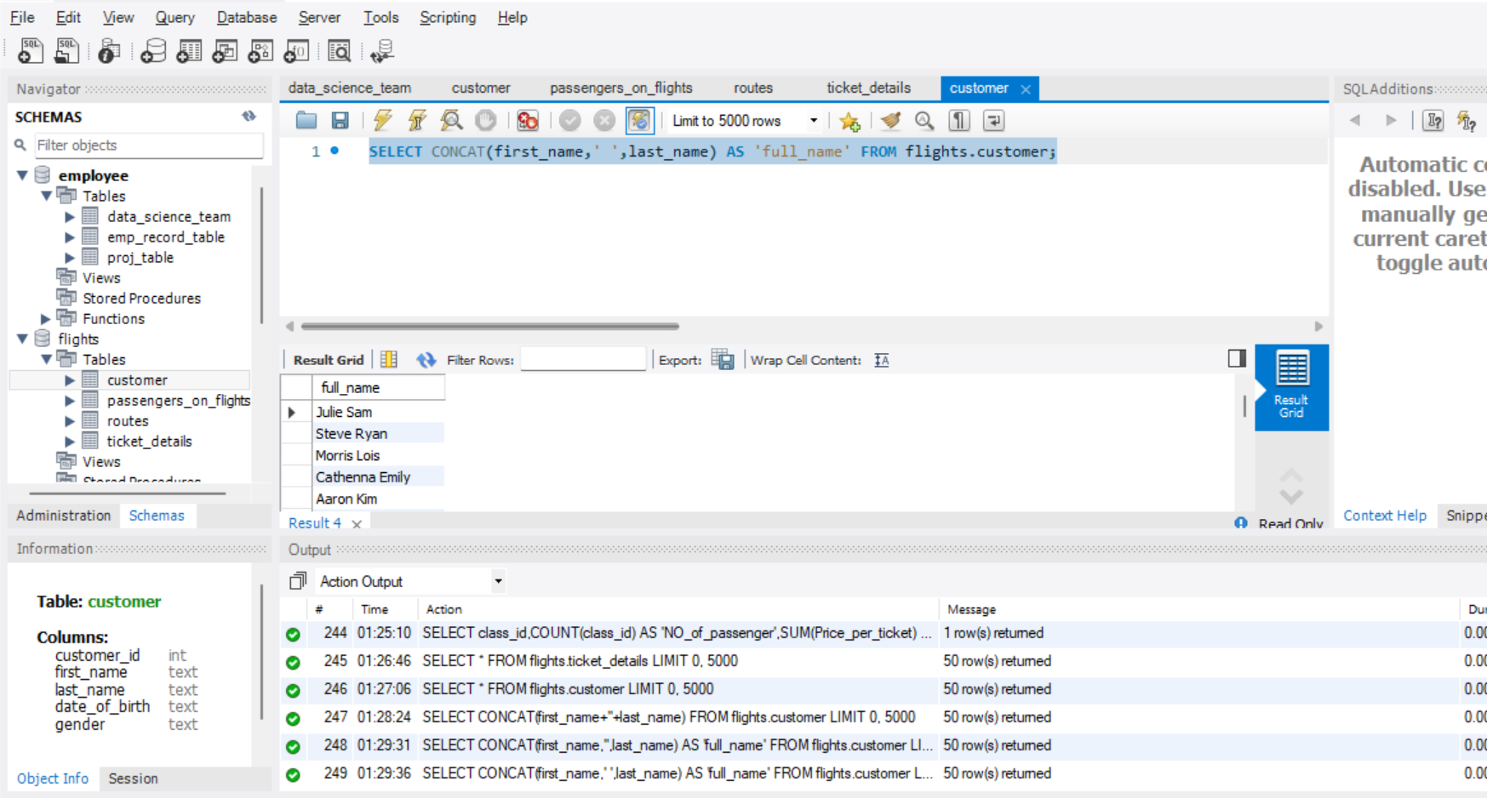

1. Write a query to extract the customers who have registered and booked a ticket. Use data from the customer and ticket_details tables.

**QUERY: SELECT t1.customer_id,CONCAT(t2.first_name,' ',t2.last_name) AS 'NAME',count(t1.no_of_tickets) AS 'NUMBER_of_tickets'**

**FROM flights.ticket_details t1**

**INNER JOIN flights.customer t2**

**ON t1.customer_id = t2.customer_id**

**GROUP BY t1.customer_id, NAME** 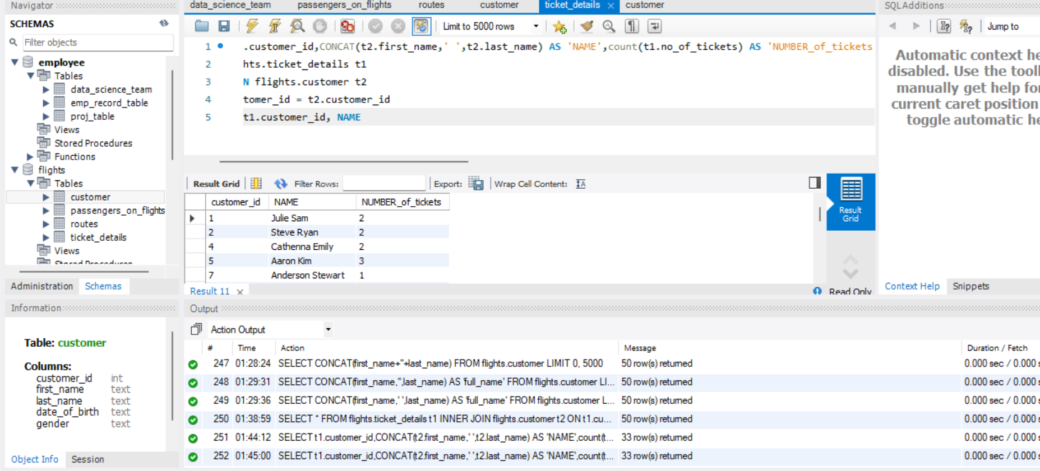

1. Write a query to identify the customer’s first name and last name based on their customer ID and brand (Emirates) from the ticket_details table.

**QUERY: SELECT * FROM(SELECT t1.customer_id,first_name,last_name,brand,count(*) OVER(PARTITION BY brand) AS'number_of_tickets'**

**FROM flights.customer t1**

**JOIN flights.ticket_details t2**

**ON t1.customer_id = t2.customer_id)t**

**WHERE t.brand = 'Emirates'**

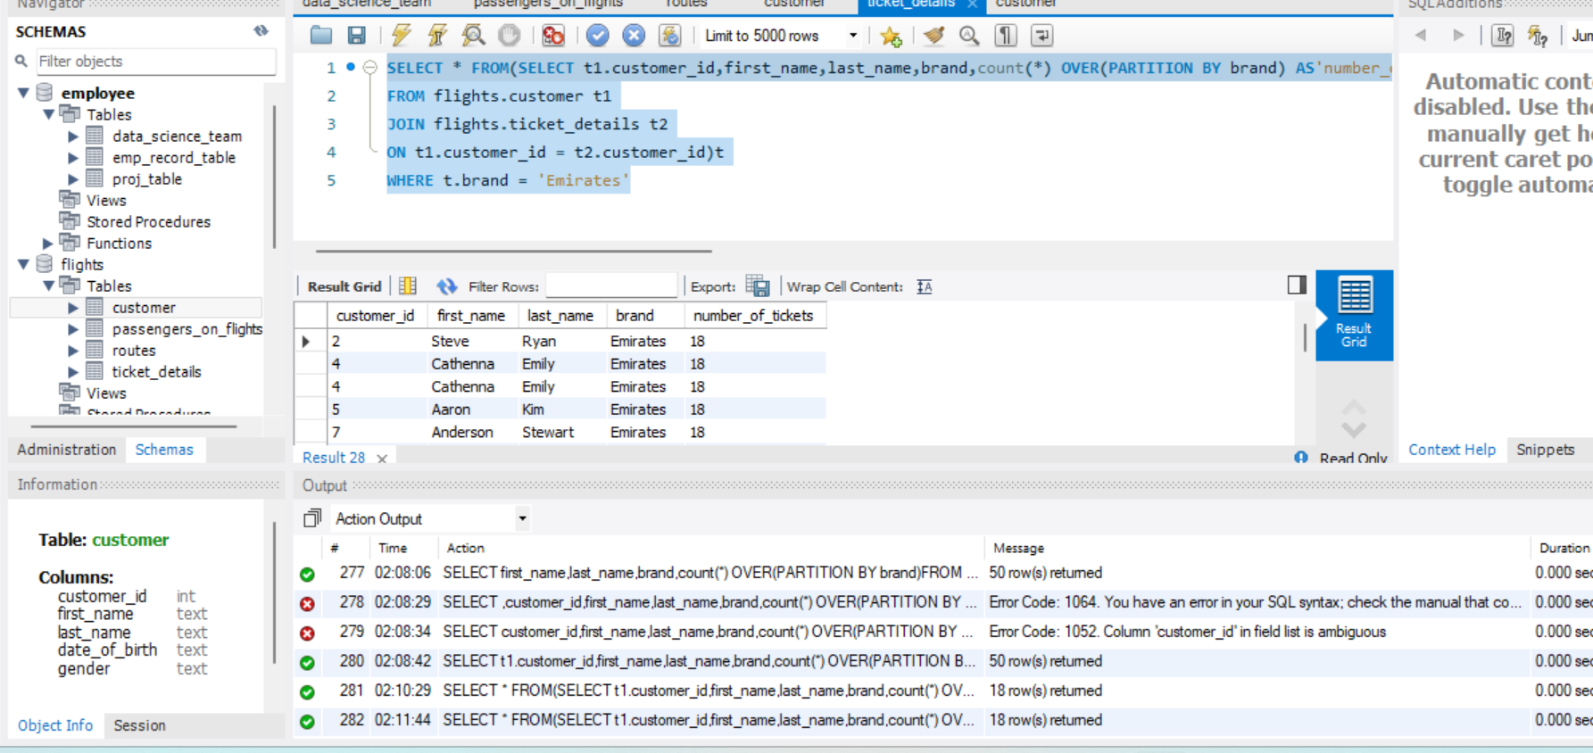

1. Write a query to identify the customers who have travelled by *Economy Plus* class using Group By and Having clause on the passengers_on_flights table.

**QUERY: SELECT customer_id, class_id FROM flights.passengers_on_flights**

**GROUP BY customer_id, class_id**

**HAVING class_id = 'Economy Plus'**

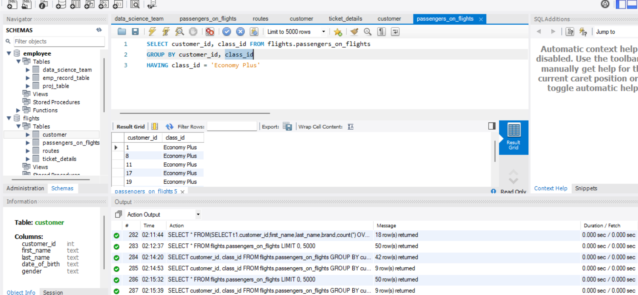

1. Write a query to identify whether the revenue has crossed 10000 using the IF clause on the ticket_details table.

**QUERY: SELECT * FROM flights.ticket_details;**

**SELECT IF(sum(no_of_tickets*price_per_ticket)>10000,'Revenue crossed 10000','Revenue less then 10000') as 'Revenue status'**

**FROM flights.ticket_details** 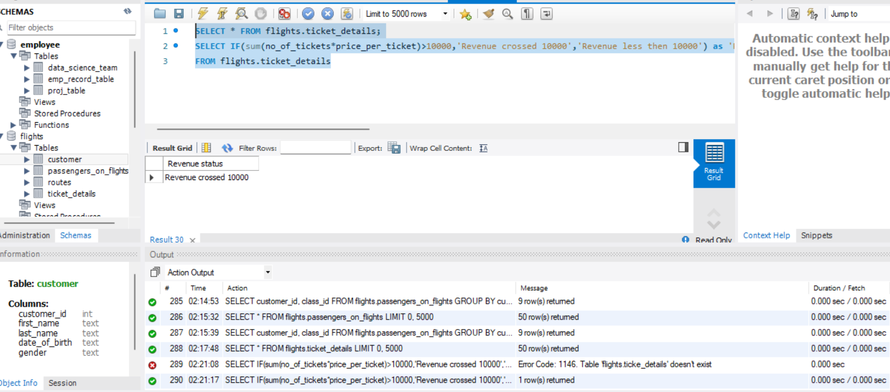

1. Write a query to create and grant access to a new user to perform operations on a database.

**QUERY:** **CREATE USER 'new_user' @ 'localhost' IDENTIFIED BY 'password';**

**GRANT ALL PRIVILEGES ON *.* TO 'new_user'@'localhost';**

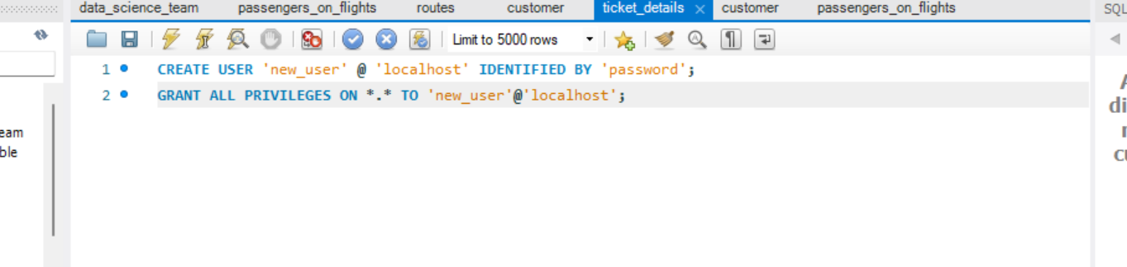

1. Write a query to find the maximum ticket price for each class using window functions on the ticket_details table.

**QUERY: SELECT *,MAX(Price_per_ticket) OVER(PARTITION BY class_id) FROM flights.ticket_details** 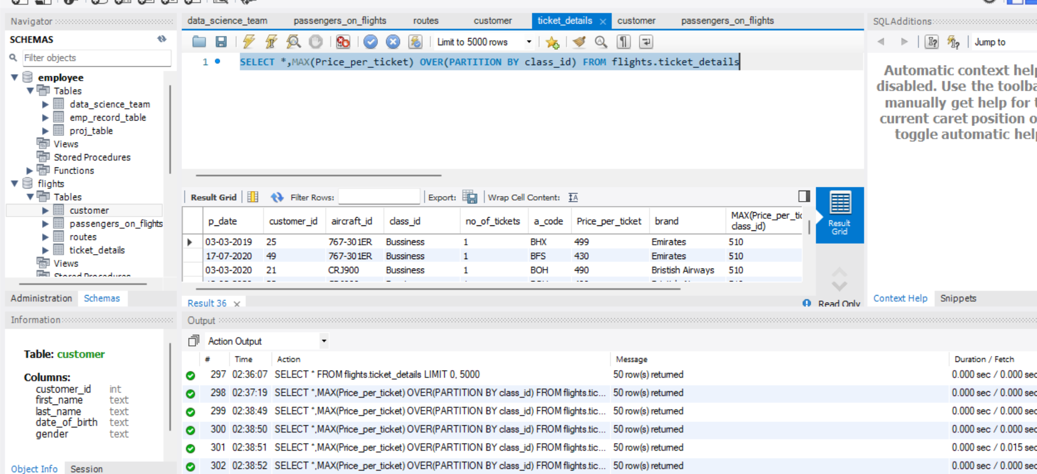

1. Write a query to extract the passengers whose route ID is 4 by improving the speed and performance of the passengers_on_flights table.

**QUERY:** **SELECT t1.customer_id,t2.first_name,t2.last_name FROM flights.passengers_on_flights t1**

**LEFT JOIN flights.customer t2**

**ON t1.customer_id = t2.customer_id**

**WHERE route_id = 4**

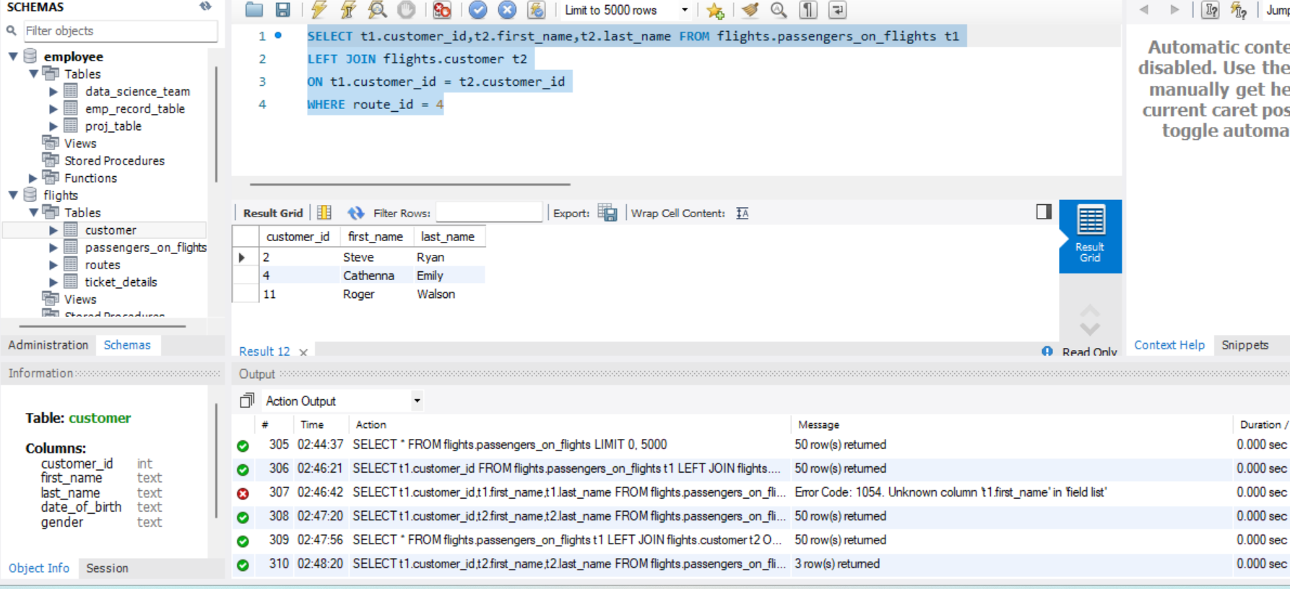

1. For the route ID 4, write a query to view the execution plan of the passengers_on_flights table.

**QUERY: SELECT aircraft_id,depart,arrival,travel_date,flight_num FROM flights.passengers_on_flights**

**WHERE route_id=4** 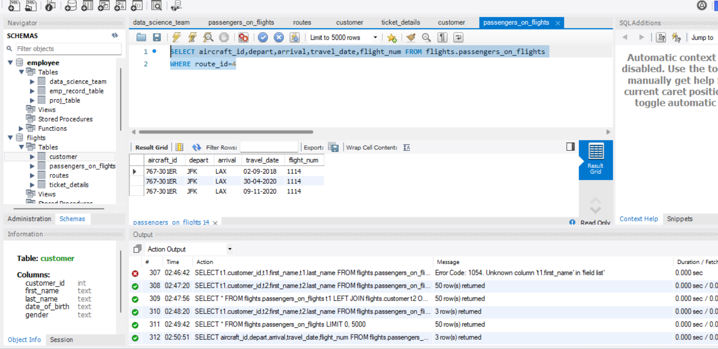

1. Write a query to calculate the total price of all tickets booked by a customer across different aircraft IDs using rollup function.

**QUERY:** **SELECT SUM(Price_per_ticket),aircraft_id FROM flights.ticket_details**

**GROUP BY aircraft_id WITH ROLLUP** 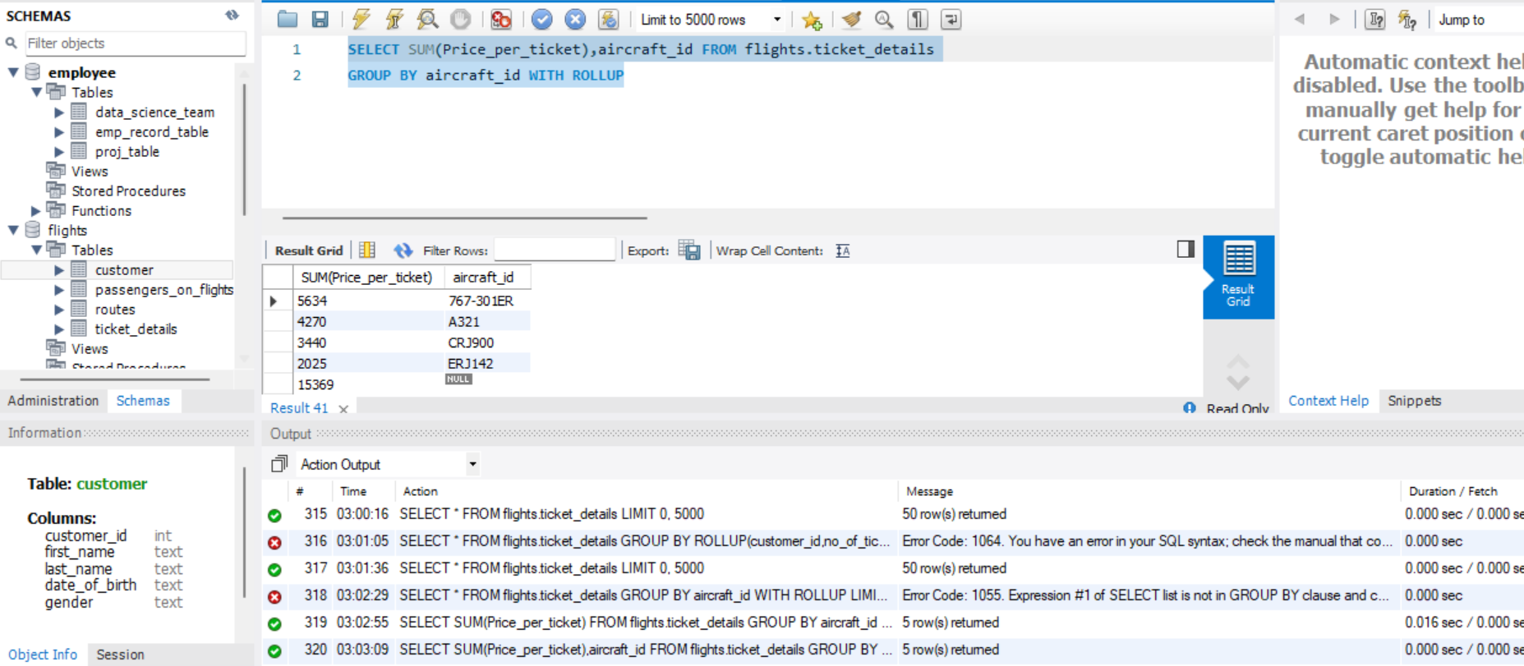

1. Write a query to create a view with only business class customers along with the brand of airlines.

**QUERY: CREATE VIEW brand**

**AS**

**SELECT first_name,last_name,t1.customer_id,class_id FROM flights.customer t1**

**JOIN flights.ticket_details t2**

**ON t1.customer_id = t2.customer_id**

**WHERE class_id = 'Bussiness'**

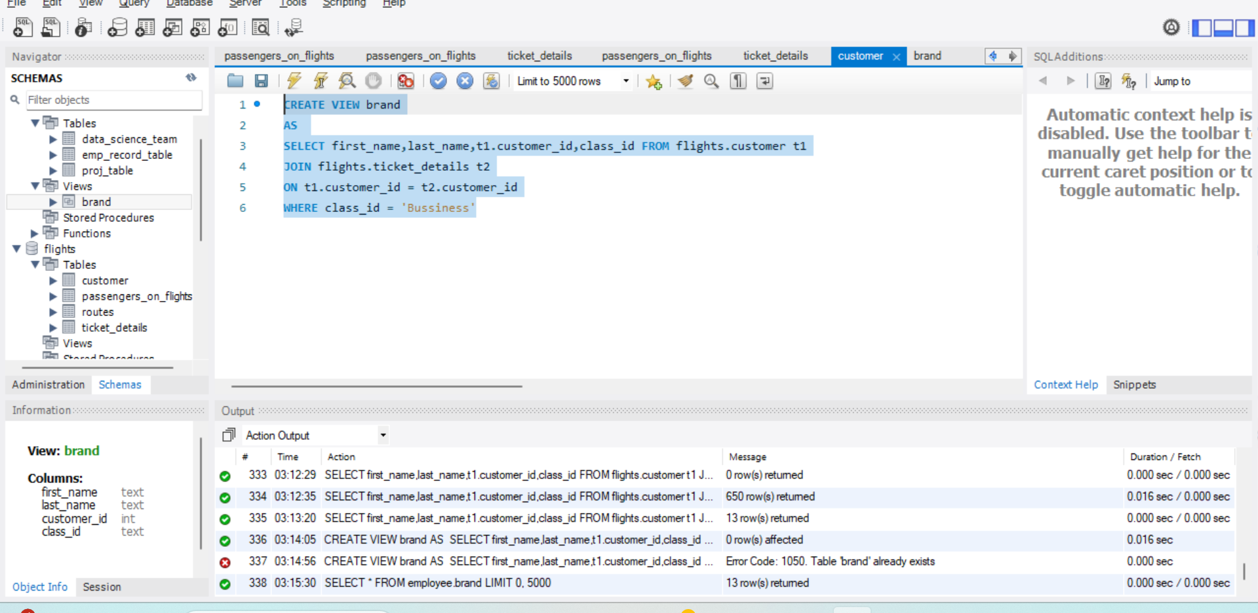

1. Write a query to create a stored procedure to get the details of all passengers flying between a range of routes defined in run time. Also, return an error message if the table doesn't exist.

QUERY: CREATE DEFINER=`root`@`localhost` PROCEDURE `route_det`(IN route1 INT, IN route2 INT)

BEGIN

DECLARE continue handler for sqlstate'42S02'

BEGIN

SELECT 'No Records Available' as Message;

END;

SELECT t1.route_id, t3.first_name, t3.last_name, t2.customer_id FROM flights.routes t1

JOIN flights.passengers_on_flights t2

ON t1.route_id = t2.route_id

LEFT JOIN flights.customer t3

USING (customer_id)

WHERE t1.route_id BETWEEN route1 AND route2;

SELECT * FROM ROUTE;

END

CALL route_det(2,4) 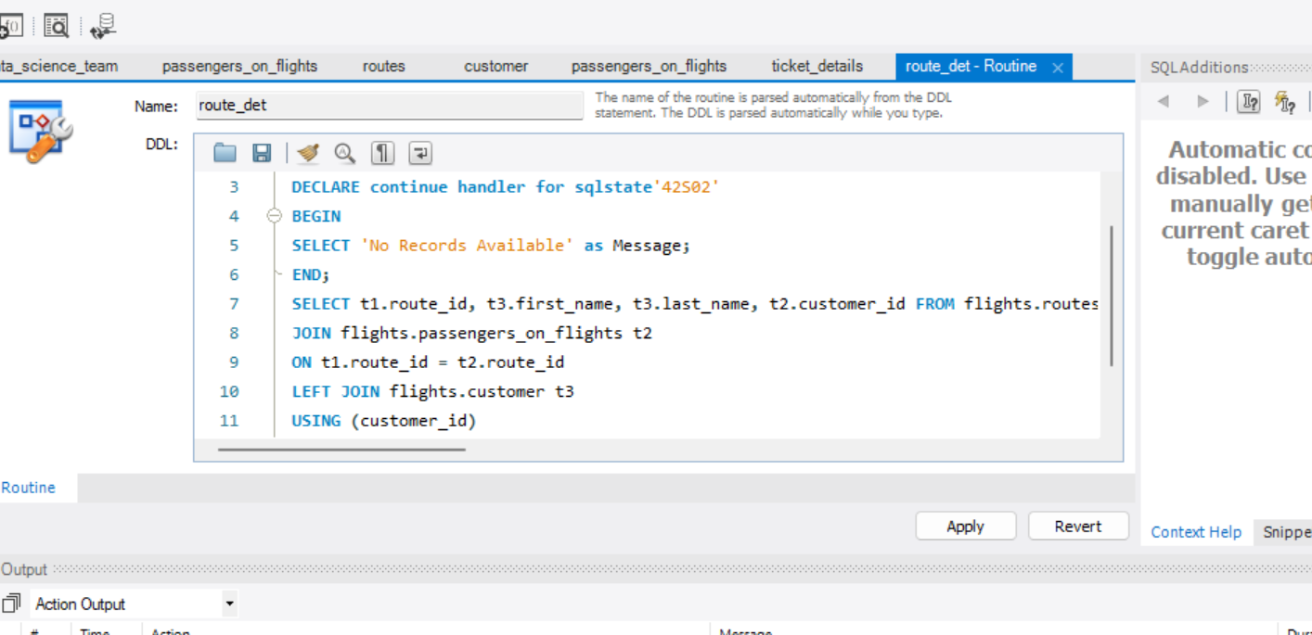 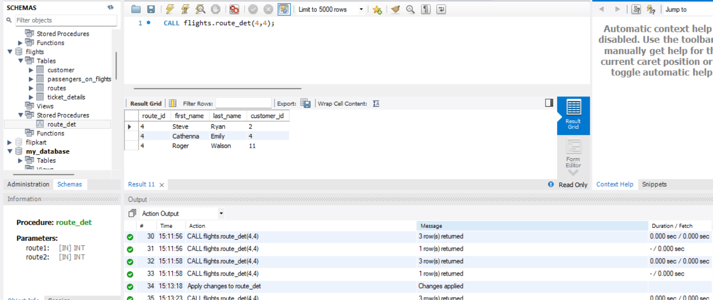

1. Write a query to create a stored procedure that extracts all the details from the routes table where the travelled distance is more than 2000 miles.

**QUERY:**

**DELIMITER &&**

**CREATE PROCEDURE distance_calc()**

**BEGIN**

**SELECT * FROM flights.routes**

**WHERE distance_miles>2000;**

**END&&**

**DELIMITER ;** 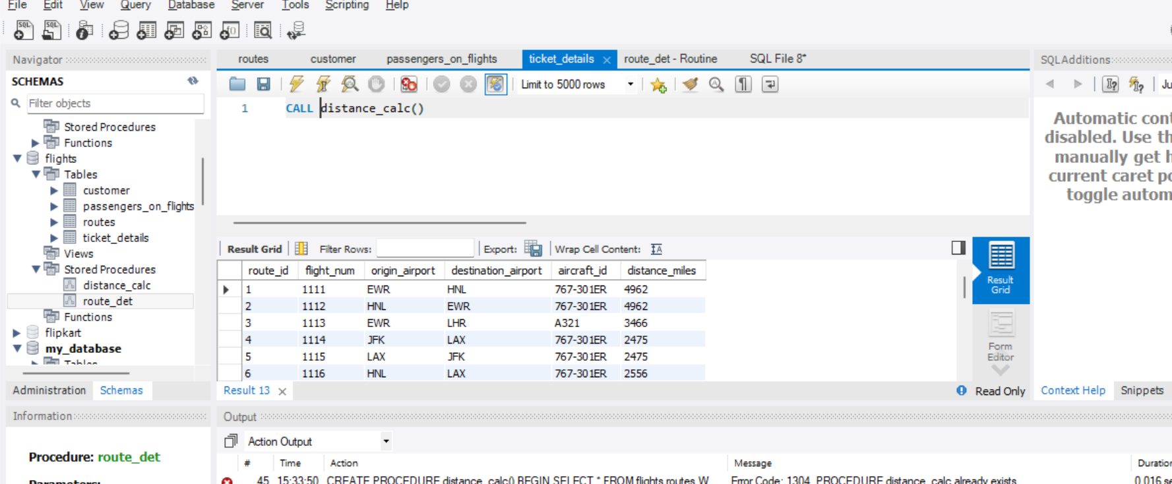 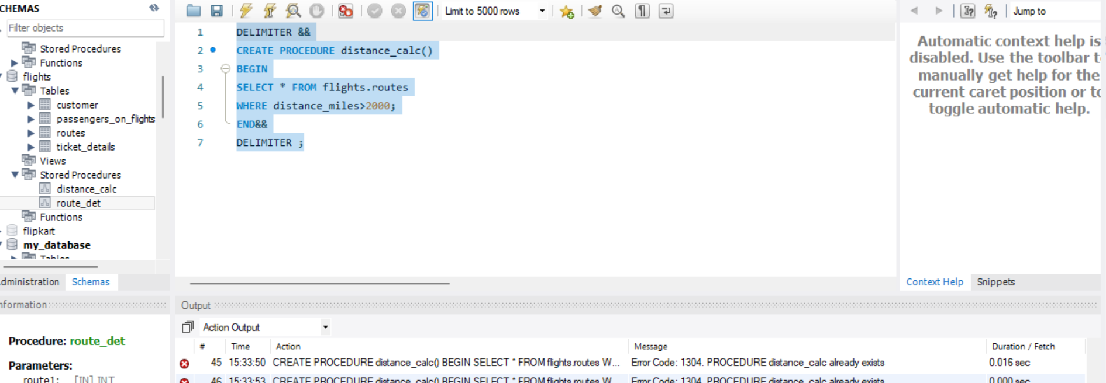

1. Write a query to create a stored procedure that groups the distance travelled by each flight into three categories. The categories are, short distance travel (SDT) for >=0 AND <= 2000 miles, intermediate distance travel (IDT) for >2000 AND <=6500, and long-distance travel (LDT) for >6500.

QUERY: DELIMITER $$

CREATE PROCEDURE GroupDistanceCategories()

BEGIN

SELECT

CASE

WHEN distance_miles >= 0 AND distance_miles <= 2000 THEN 'Short Distance Travel (SDT)'

WHEN distance_miles > 2000 AND distance_miles <= 6500 THEN 'Intermediate Distance Travel (IDT)'

WHEN distance_miles > 6500 THEN 'Long-Distance Travel (LDT)'

ELSE 'Invalid Category'

END AS DistanceCategory,

COUNT(*) AS CountFlights

FROM flights.routes

GROUP BY DistanceCategory

ORDER BY DistanceCategory;

END $$

DELIMITER ;

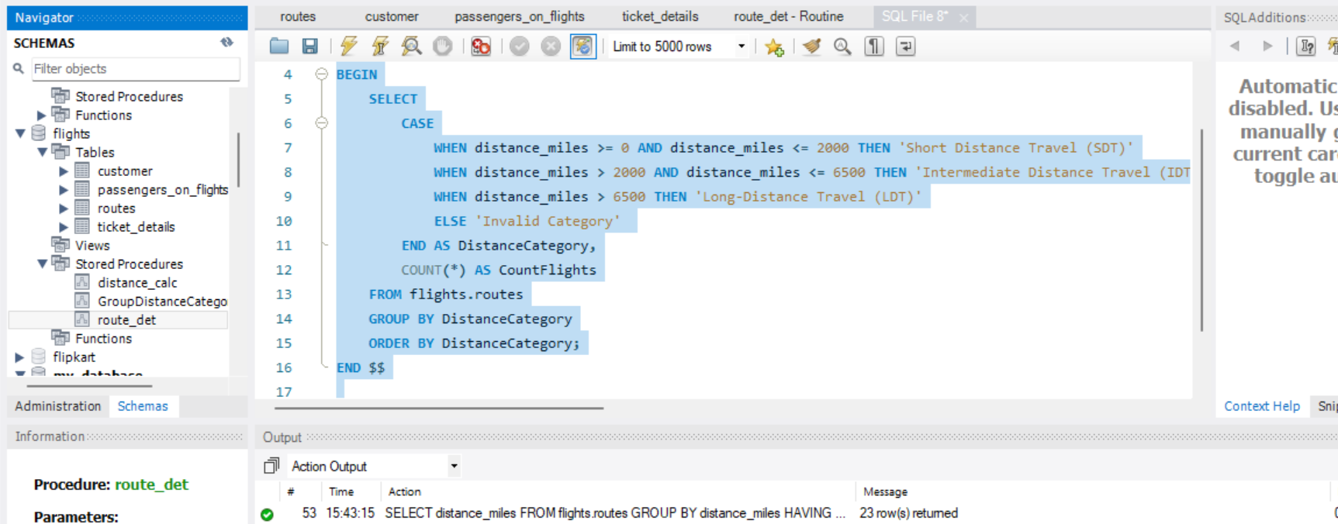

1. Write a query to extract ticket purchase date, customer ID, class ID and specify if the complimentary services are provided for the specific class using a stored function in stored procedure on the ticket_details table.

CREATE DEFINER=`root`@`localhost` PROCEDURE `servies_comp`(IN customer_id INT)

BEGIN

SELECT P_date, customer_id, class_id,

CASE

WHEN class_id = 'Bussiness' OR class_id = 'Economy Plus' then 'Complementary Servies'

else 'NO Complementary Servies'

END AS service_distribution

FROM flights.ticket_details

WHERE customer_id = customer_id;

END

